AWS CLOUD COMPUTING AND DATA ENGINEERING ASSIGNMENT

Name: Bhuvanesh L
Roll Number: 23BTRCC009
College Name: Jain University
Batch: 2027
HCL ID: HCLTFP2299117
Title: AWS Cloud Computing and Data Engineering

SQL QUERIES

Table Execution:
a). Query

CREATE DATABASE IF NOT EXISTS glue_training_db;

USE glue_training_db;

CREATE TABLE IF NOT EXISTS employees (
employee_id INT PRIMARY KEY,
name VARCHAR(100),
department VARCHAR(100),
salary DECIMAL(10,2),
city VARCHAR(100)
);

INSERT INTO employees
(employee_id, name, department, salary, city)
VALUES
(101, 'Arun', 'IT', 65000, 'Bengaluru'),
(102, 'Priya', 'HR', 52000, 'Chennai'),
(103, 'Karthik', 'IT', 78000, 'Bengaluru'),
(104, 'Divya', 'Finance', 68000, 'Coimbatore'),
(105, 'Rahul', 'HR', 48000, 'Chennai'),
(106, 'Meena', 'Finance', 72000, 'Bengaluru'),
(107, 'Vijay', 'IT', 85000, 'Hyderabad'),
(108, 'Anitha', 'Marketing', 56000, 'Chennai'),
(109, 'Ravi', 'Finance', 61000, 'Hyderabad'),
(110, 'Sneha', 'IT', 75000, 'Coimbatore');

SELECT * FROM employees;

b). Table
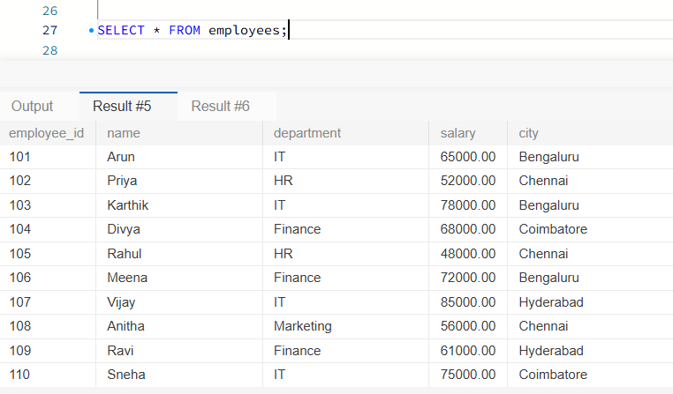

- Display selected columns

SELECT employee_id, name, department FROM employees;

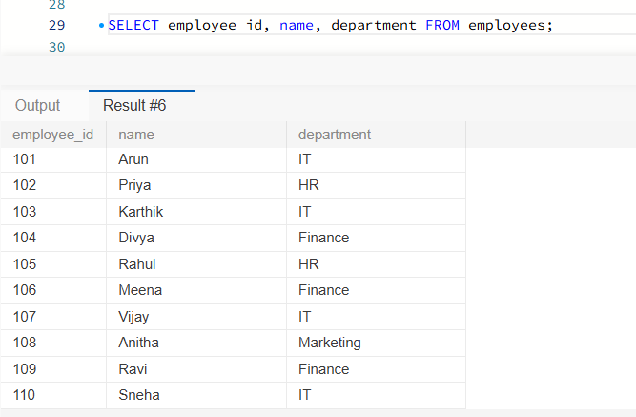

- Filter employees by salary

SELECT * FROM employees WHERE salary > 70000;
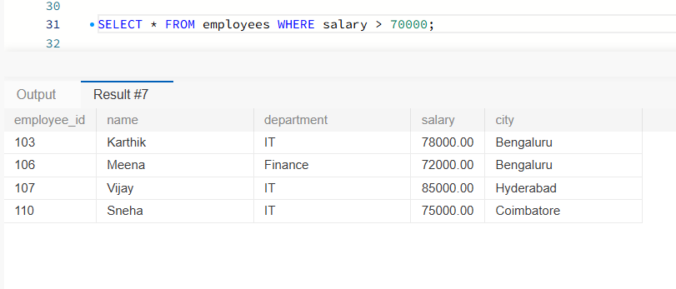

- Sort employees by salary

SELECT name, salary FROM employees ORDER BY salary DESC;
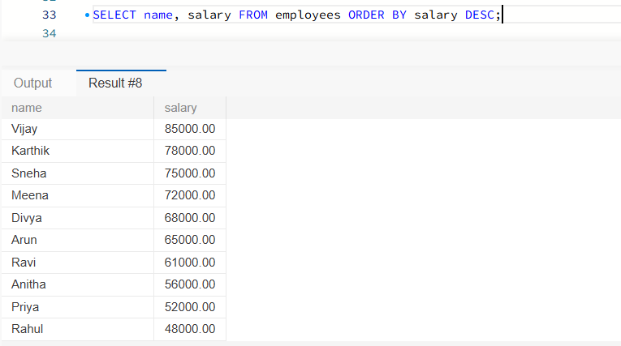

- Find average salary by department

SELECT department, AVG(salary) AS avg_salary FROM employees GROUP BY department;

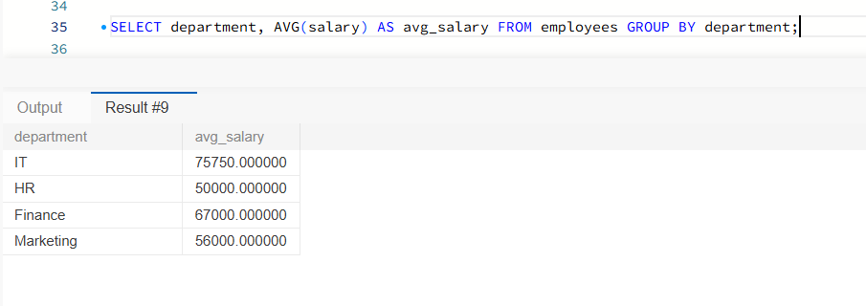

- Find departments with average salary above 65,000

SELECT department, AVG(salary) AS avg_salary FROM employees GROUP BY department HAVING AVG(salary) > 65000;

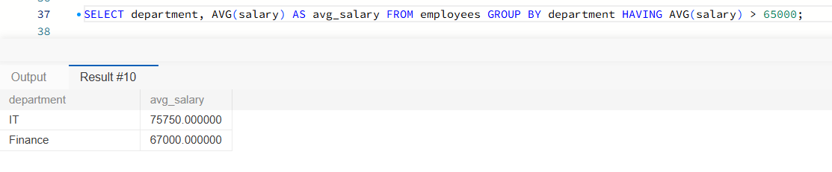

- Count employees in each department

SELECT department, COUNT(*) AS employee_count FROM employees GROUP BY department;

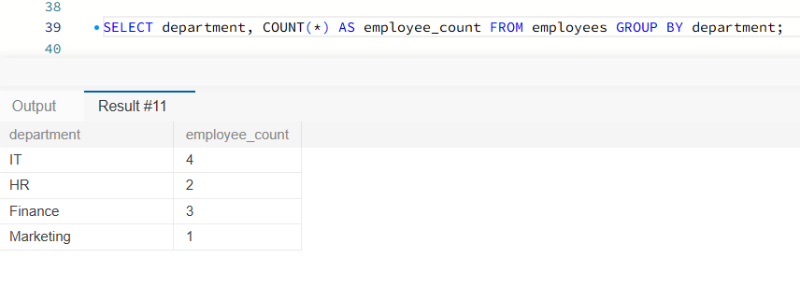

- Find employees in selected cities

SELECT name, city FROM employees WHERE city IN ('Chennai', 'Bengaluru');

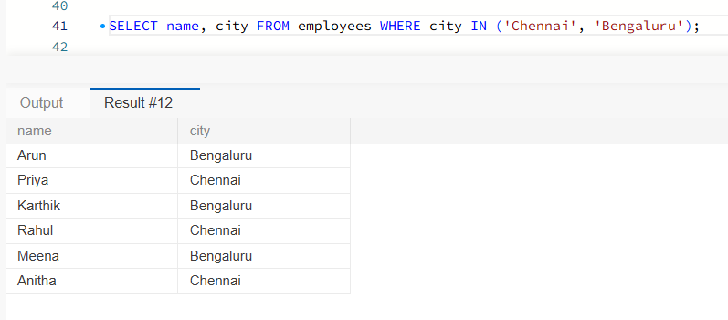

- Find names starting with A

SELECT * FROM employees WHERE name LIKE 'A%';

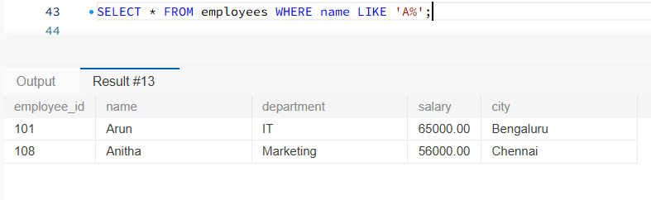

- Find the highest salary

SELECT MAX(salary) AS highest_salary FROM employees;
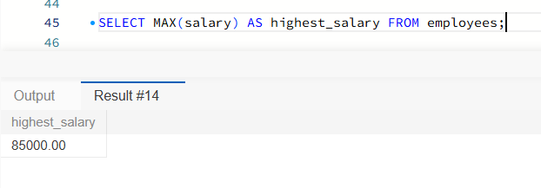

- Find employees above the overall average salary

SELECT name, salary FROM employees WHERE salary > (SELECT AVG(salary) FROM employees);
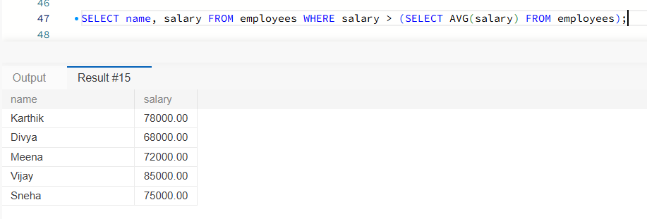

- Assign salary ranks

SELECT name, department, salary, DENSE_RANK() OVER (ORDER BY salary DESC) AS salary_rank FROM employees;
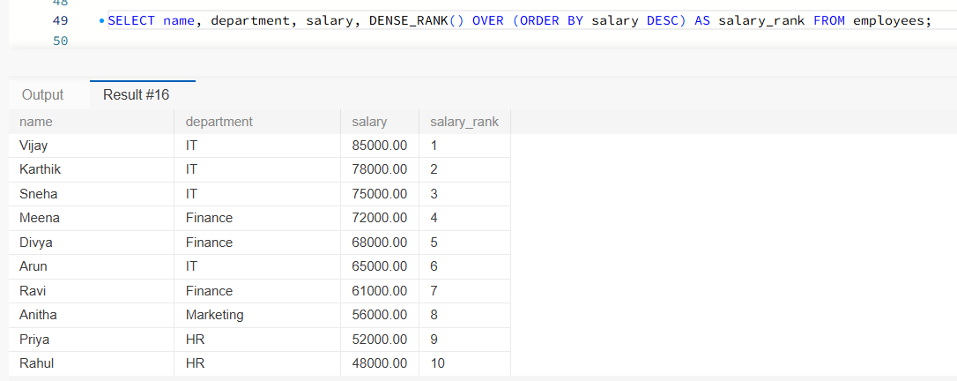

- Classify employees by salary

SELECT name, salary, CASE WHEN salary >= 75000 THEN 'High' WHEN salary >= 60000 THEN 'Medium' ELSE 'Low' END AS salary_band FROM employees;

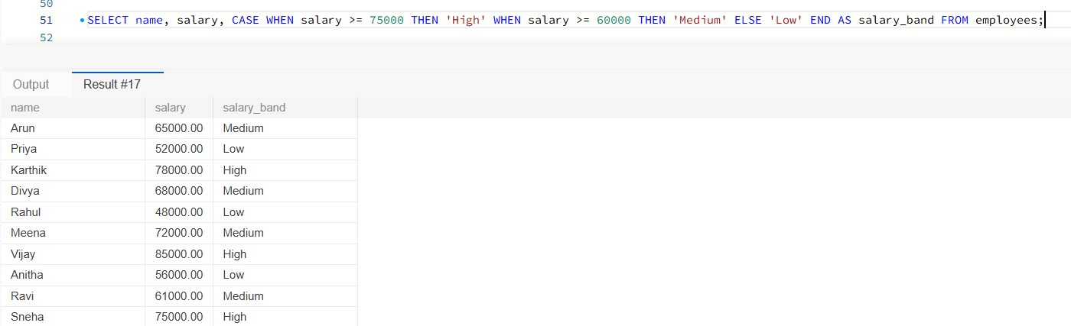

- Find the number of employees in each city

SELECT city, COUNT(*) AS total_employees FROM employees GROUP BY city ORDER BY total_employees DESC;
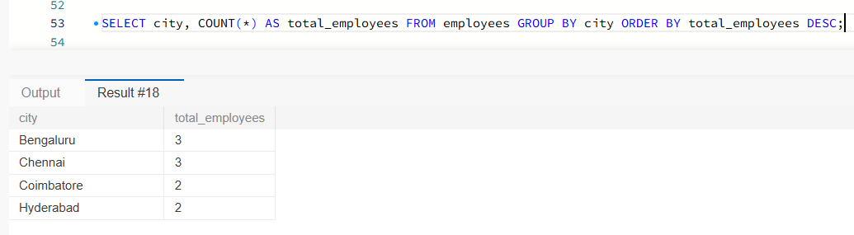

- Display employees earning between 50,000 and 75,000

SELECT name, salary FROM employees WHERE salary BETWEEN 50000 AND 75000 ORDER BY salary;

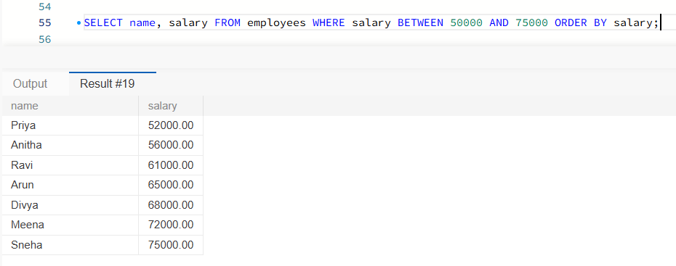

- Find the lowest salary in each department

SELECT department, MIN(salary) AS lowest_salary FROM employees
GROUP BY department;

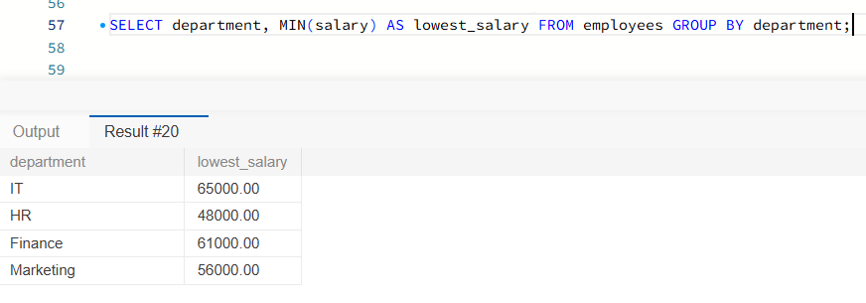

Linux Practice

Execution of Linux Commands in Ubuntu

- Print current directory

pwd

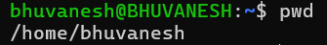

- List files

Ls

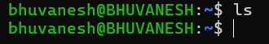

- Create a project folder

mkdir -p ~/data_project

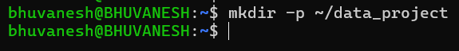

- Enter the project folder

cd ~/data_project

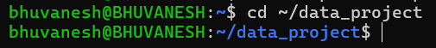

- Show hidden files

ls -la

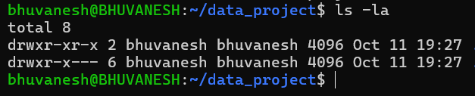

- Create a text file

touch notes.txt

- Write sample data

printf 'INFO ETL started\nERROR invalid row\nINFO ETL completed\n' > app.log

- Display file contents

cat app.log

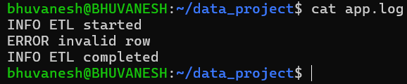

- Search for ERROR

grep 'ERROR' app.log
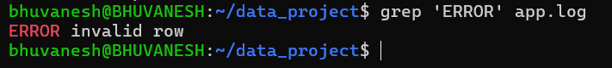

- Copy the log file

cp app.log app_backup.log

- Rename the text file

mv notes.txt readme.txt

- Change file permissions

chmod 640 app.log

- Verify permissions

ls -l app.log

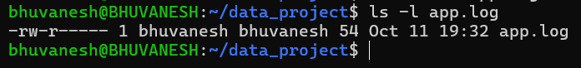

- Display running processes

Ps

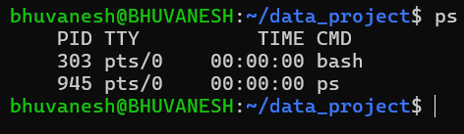

- Check available disk space

df -h
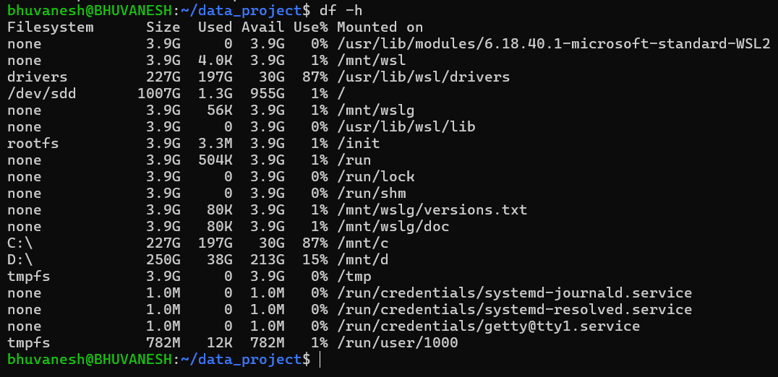

AWS Account / Region

- AWS Account

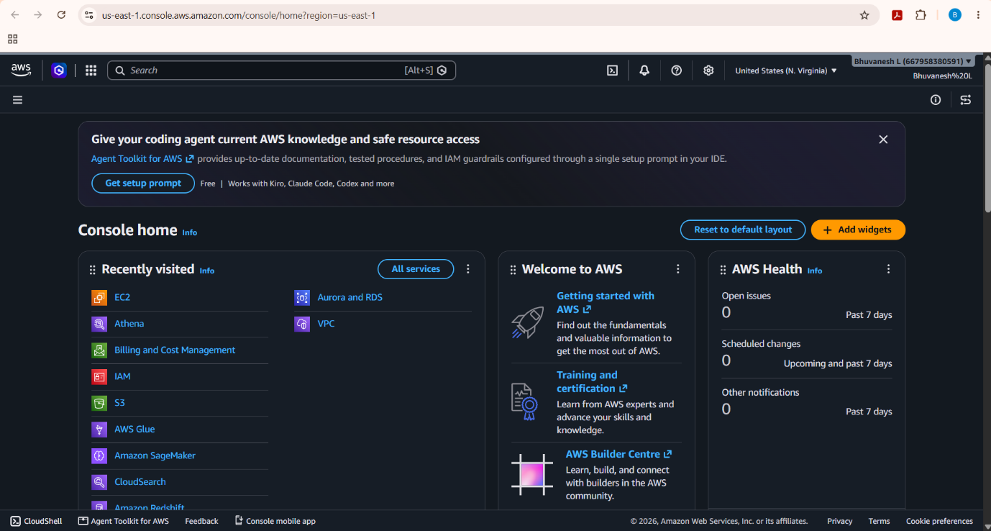

- AWS Region
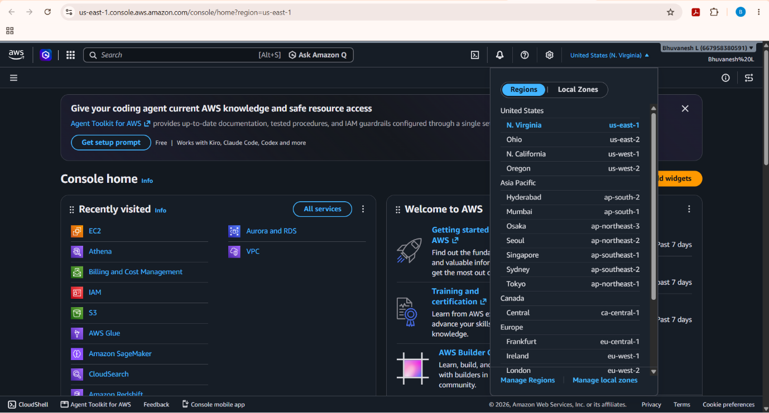

Amazon S3

- Creation of S3 Bucket
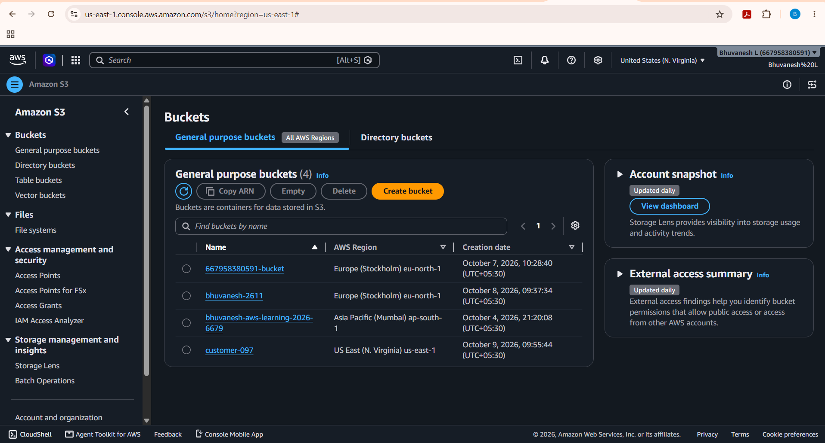

- Adding name to the S3 Bucket
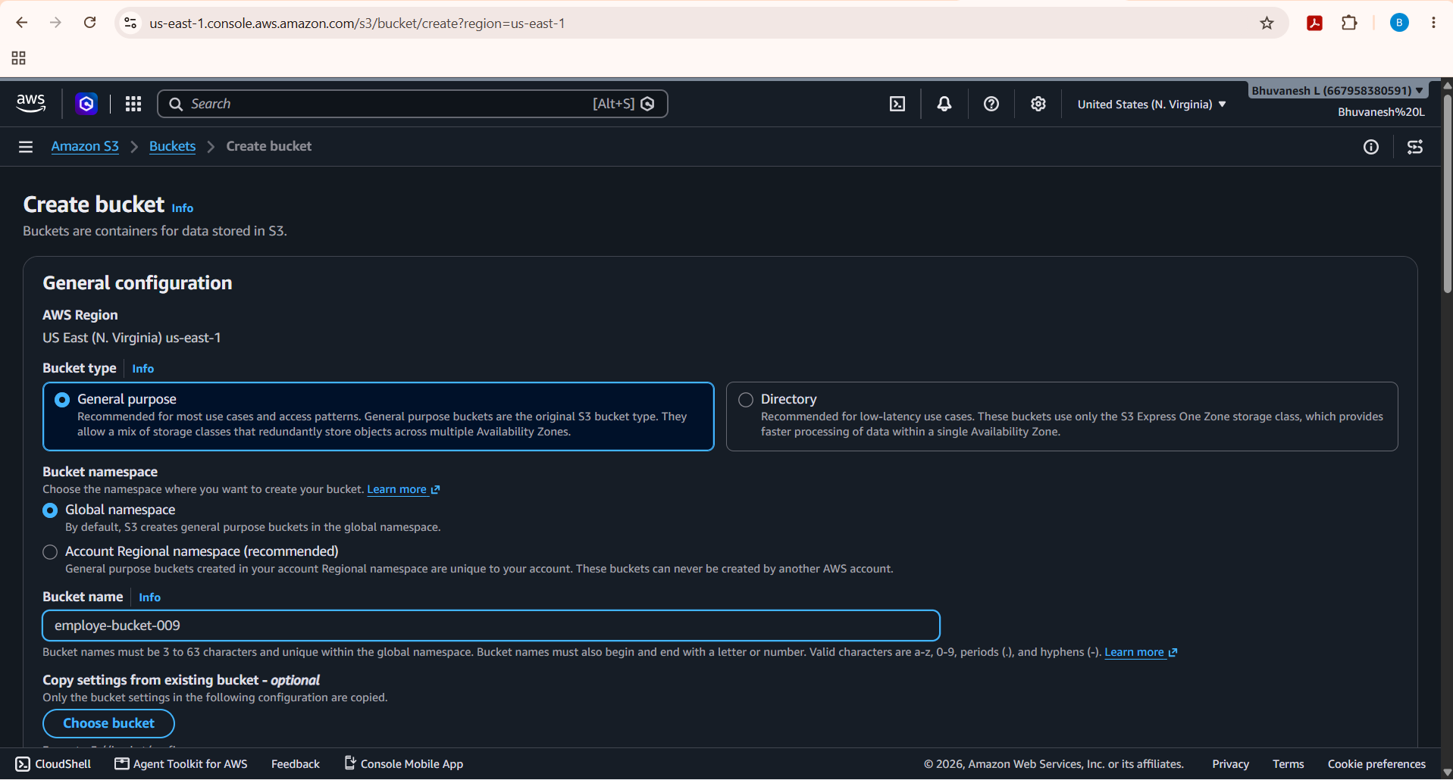
- Successfully creating the bucket
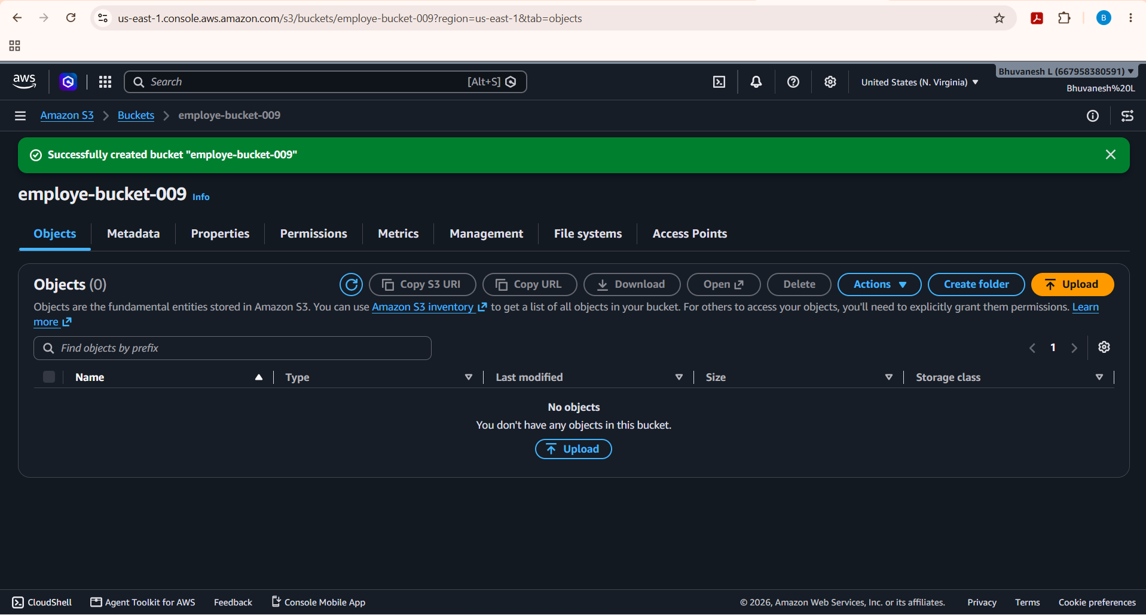

- Creating a folder in S3 Bucket
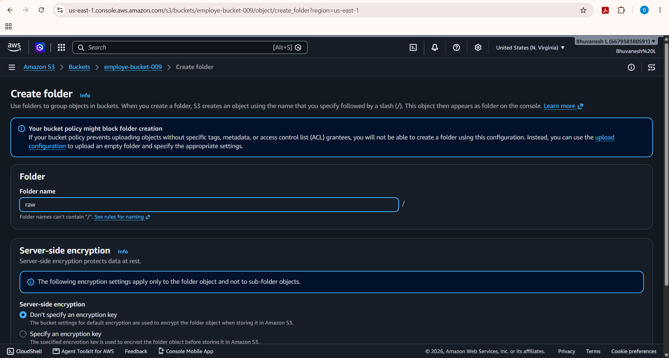

- Successfully creating the folder in S3 Bucket
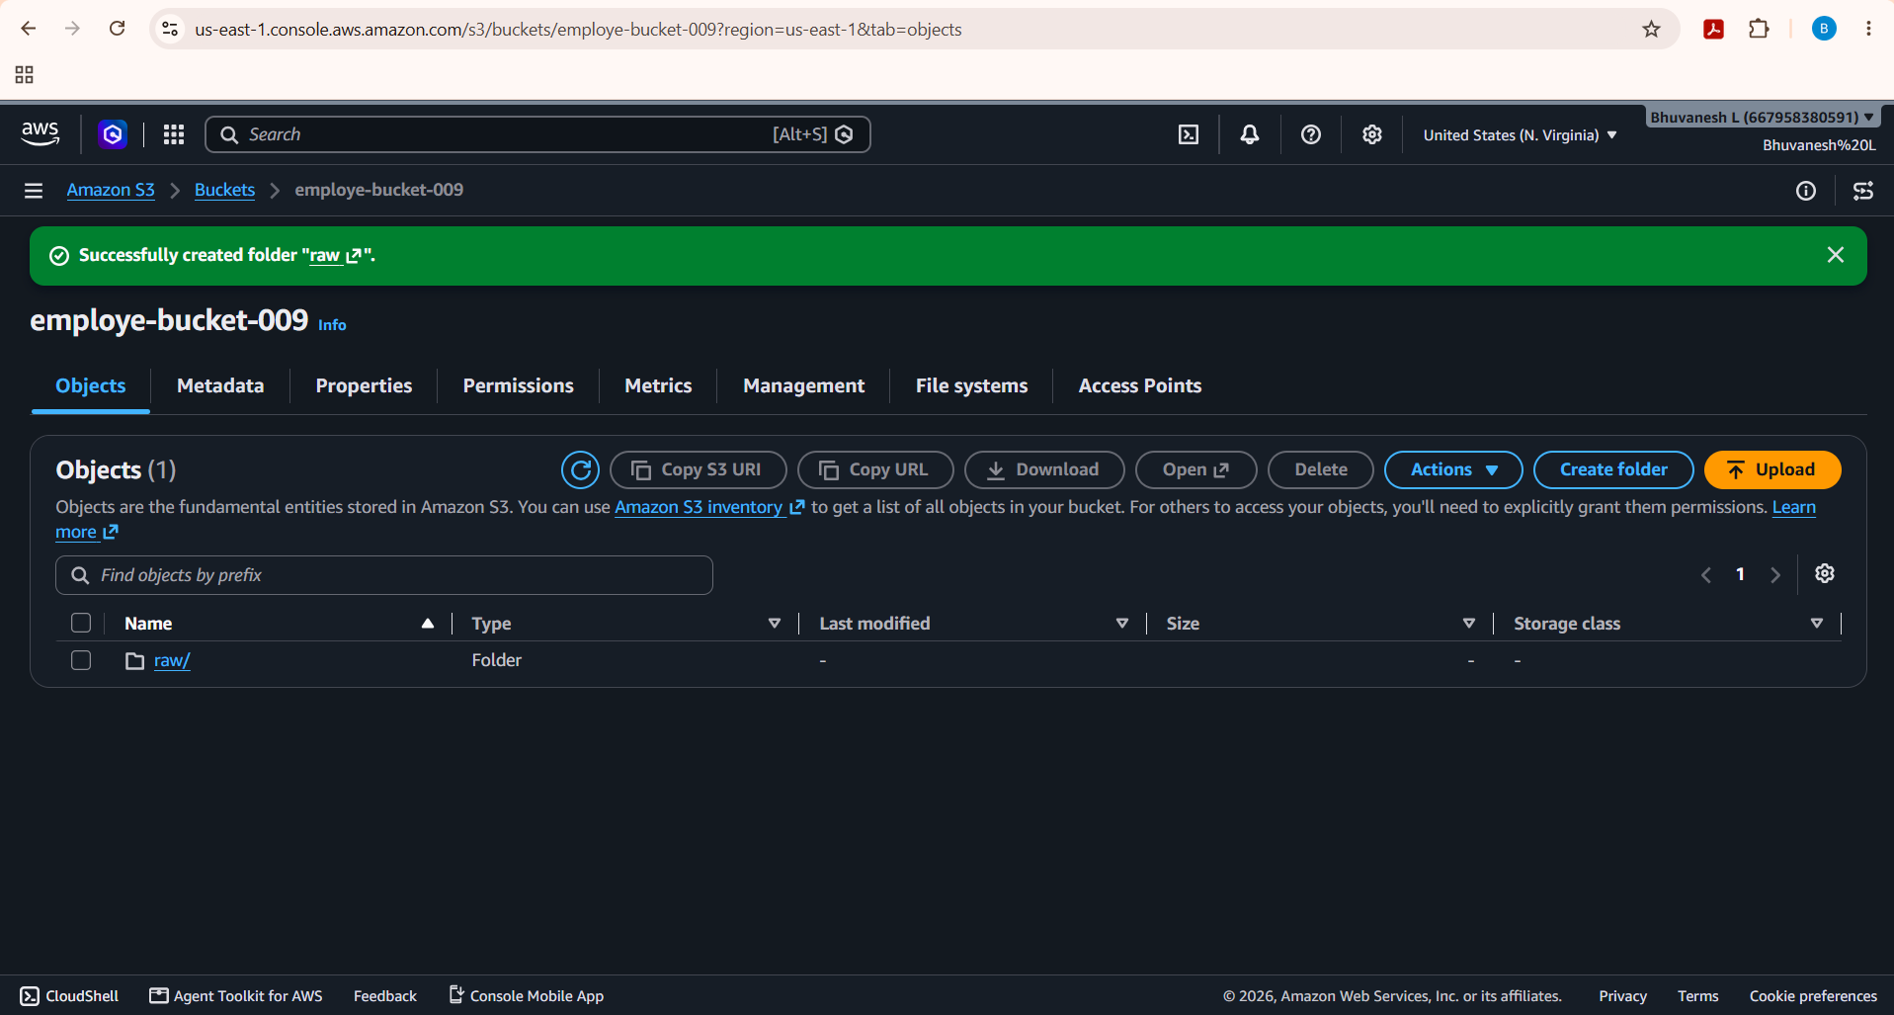

- Uploading a .csv file inside the folder
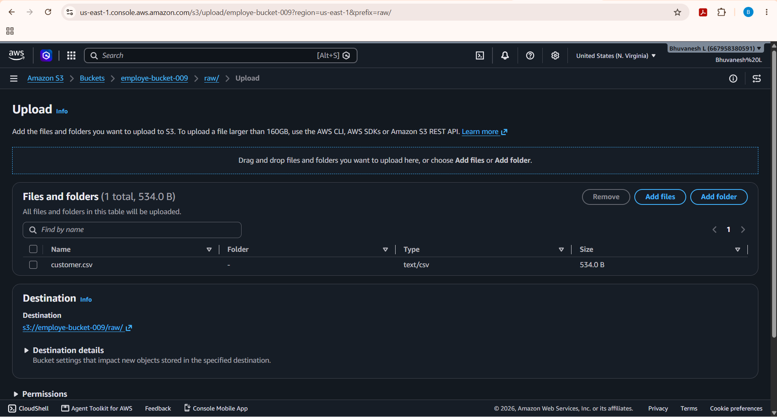

- Successfully uploading the file inside the folder
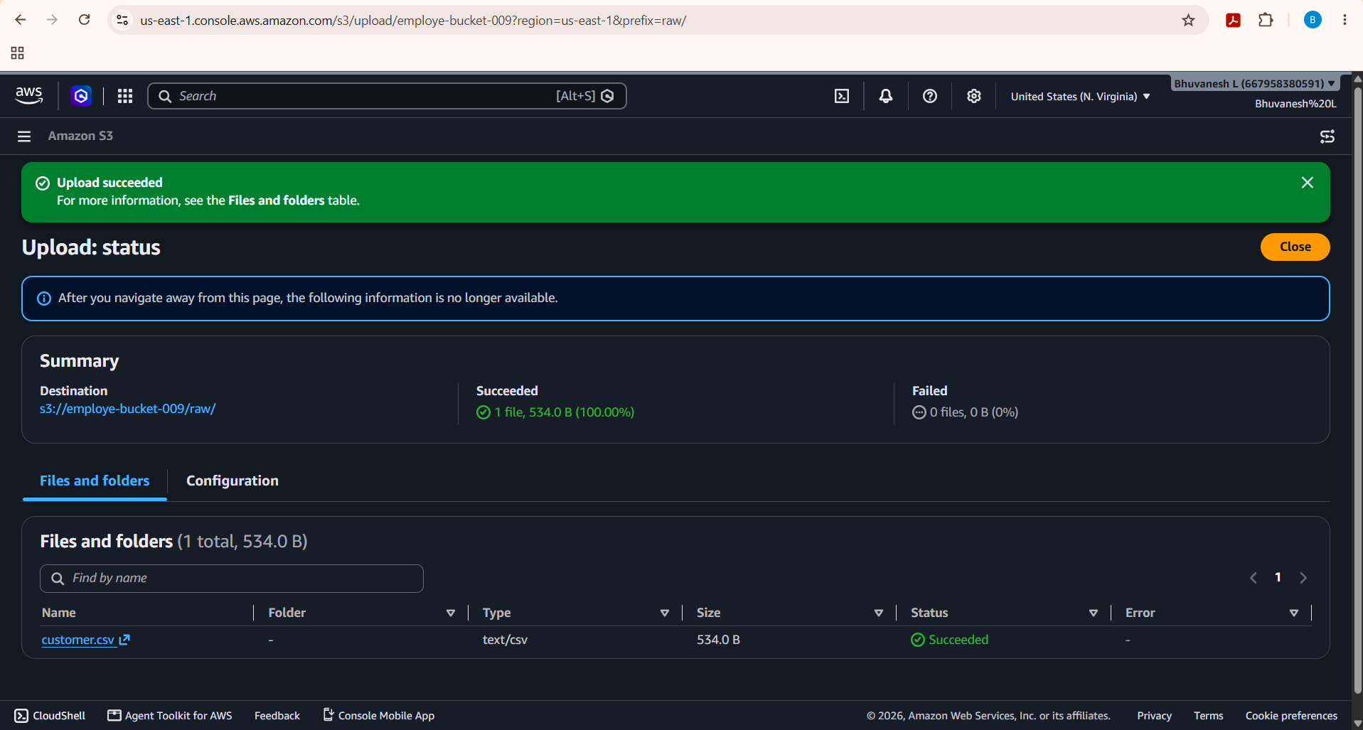

IAM

- Select trusted entity as AWS service
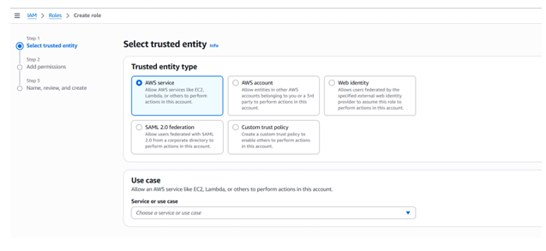

- Use case selected as Glue
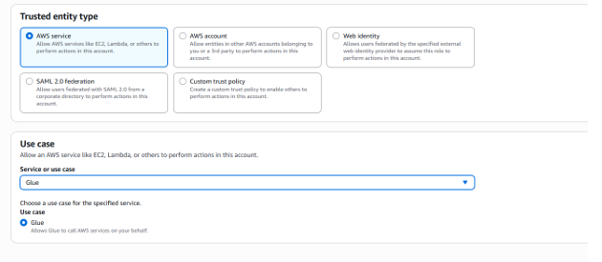

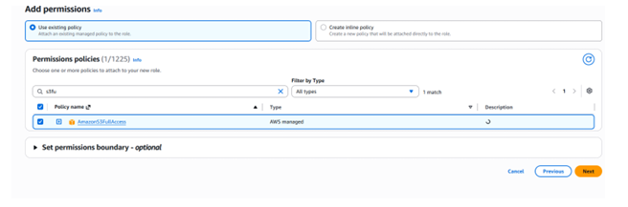
- Add permissions: AmazonS3FullAccess policy selected

- Role mygluerole created
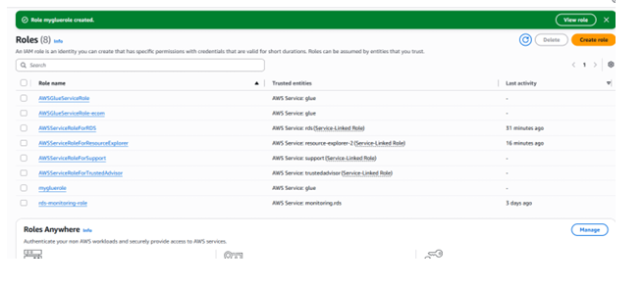

- IAM role used for AWS Glue: AWSglueEmployeerole with the AmazonS3FullAccess and AWSGlueServiceRole policies
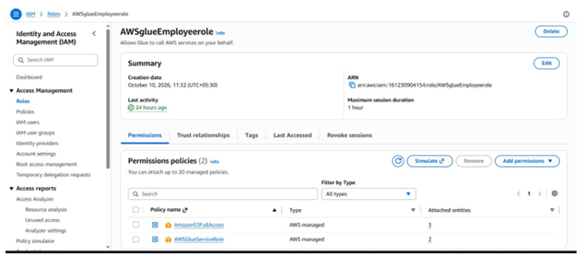

AWS Glue Database

AWS Glue Data Catalog: database glue_training_db with its properties and tables
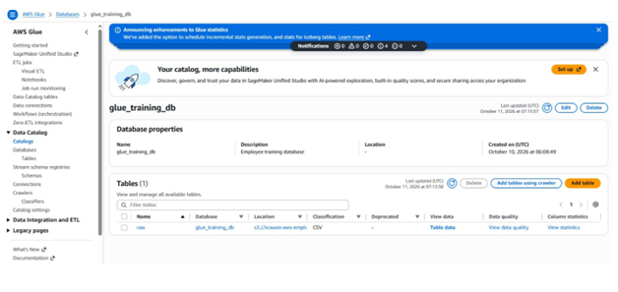

Glue Crawler

- Crawler employees-crawler: S3 data source (raw/ folder), IAM role AWSglueEmployeerole and target database glue_training_db
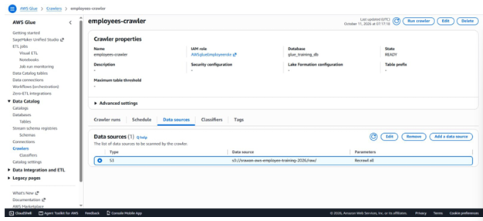

- Crawler configuration: review of the crawler properties, data source, security settings and output (schedule: on demand)
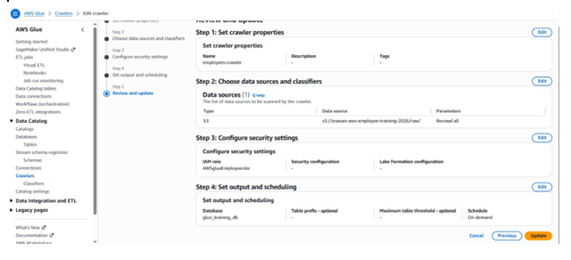

Crawler Execution

Crawler execution: the crawler runs show the status Completed and the crawler state is READY
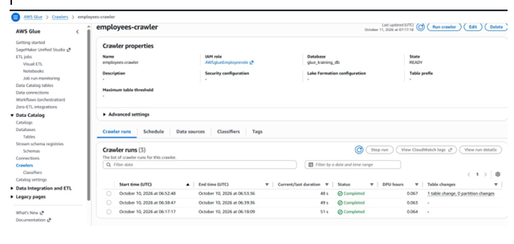

Glue Data Catalog

Table raw created by the crawler in glue_training_db, with its schema and data types
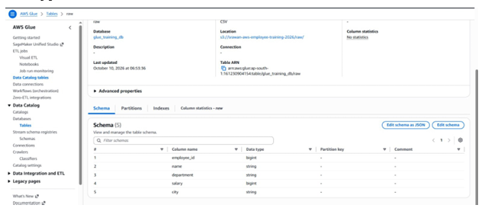

Glue Visual ETL

Visual ETL job: Data Catalog source, Drop Fields transform and Amazon S3 target
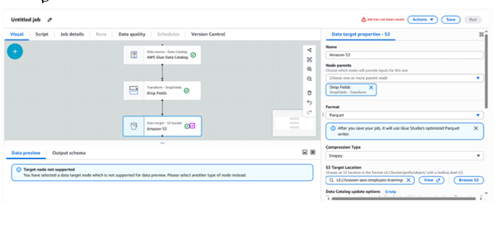

Glue Transformation

Transformation: Drop Fields node connected to the AWS Glue Data Catalog source
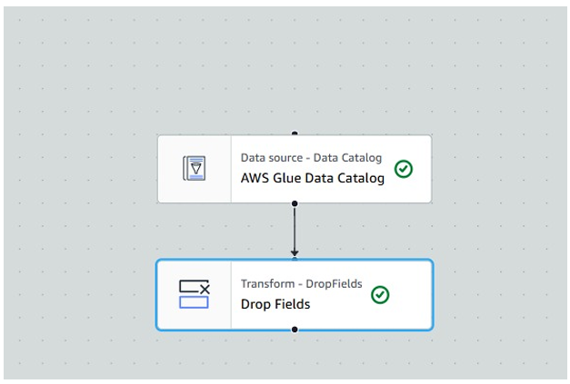

S3 Target Configuration

S3 target configuration: Parquet format with Snappy compression and the S3 target location
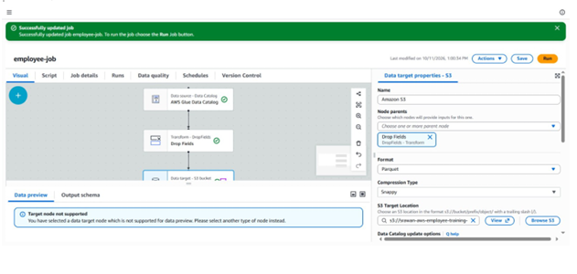

Glue ETL Job Execution

- Job employee-job started: run status Running

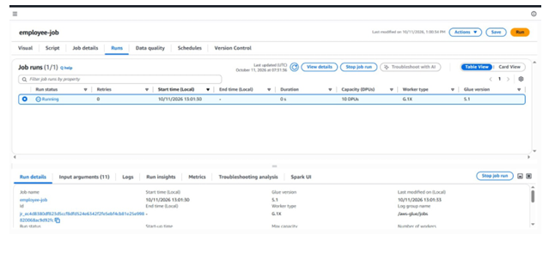

- Job employee-job: run status Succeeded

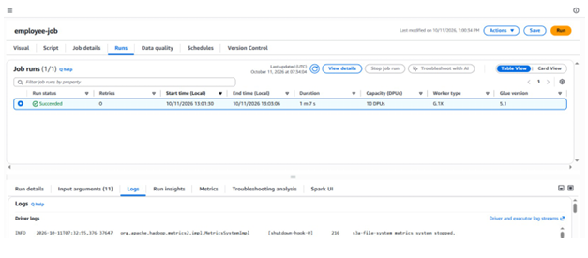

Final S3 Output

Output in the curated/ folder: a Parquet file generated by the job

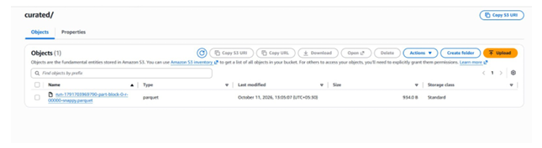

Final Explanation

AWS Glue ETL Workflow
- Amazon S3 – Raw Data

I started by creating an S3 bucket to store the employee dataset. I uploaded the employees.csv file into the raw/ folder. This folder keeps the original data unchanged so that it can be used whenever needed.

- AWS Glue Crawler

The Glue Crawler scans the CSV file stored in the raw folder. It identifies the column names and their data types automatically. This saves me from having to define the entire table structure manually.

- Glue Data Catalog

After the crawler runs successfully, the detected table information is stored in the Glue Data Catalog. I used the database glue_training_db, where the employees table contains details about the employee ID, name, department, salary and city.

- AWS Glue Visual ETL

I used AWS Glue Visual ETL to create the data processing workflow. The employees table from the Data Catalog acts as the source, and I connected it to the transformation and S3 target nodes. This makes it easier to understand how data moves through the pipeline.

- Data Transformation

In the transformation stage, I used the Drop Fields operation to remove the city column because it was not required in the final output. The remaining employee information is passed to the next stage without that column.

- Amazon S3 – Curated Data

After the transformation, the ETL job writes the processed employee data into the curated/ folder of the S3 bucket. I configured the output format as Parquet, which is suitable for storing structured data for further processing and analysis.

- Final Output

Once the ETL job completes successfully, the generated Parquet file can be checked in the curated folder. The original CSV remains in the raw folder, while the transformed data is stored separately. This workflow helped me understand how AWS services work together to process and organize data.

